Every year, in partnership with the Solidaridad en Marcha, Catholic churches throughout the city of Lima, Peru deliver thousands of Christmas gift boxes to the poorest residents in the city. The campaign, called Caja Del Amor, has been in operation for years and has subsequently built long-term and well-sustained relationships with many community leaders in these areas.

The list of gift recipients is built in coordination with the local community leaders, most of whom oversee around 150 families. These leaders choose the 5 to 10 families in most need of assistance in their respective community to receive the gift boxes.

These networks served as a point of strength when we began to explore the creation of an in-depth survey to better understand the poorest urban populations in Peru. However, our focus needed to also be on action-ability of insight and the concrete opportunity of enacting positive change in the lives those we surveyed.

Therefore, we decided to focus on a region of high need, and an area where Solidaridad en Marcha had a significant footprint. This process of elimination lead us to the region of Pamplona Alta near the San Juan de Miraflores municipality of Lima.

Pamplona Alta is a shanty town riddled with extreme poverty, it has an absence of infrastructure, and a large portion of its community is without access to many basic human needs. The region has no public works, no paved roads, no public electricity, nor public access to water and sewage. If these services exist at all, they are provided by private companies at a premium price.

Water trucks provide the only (non-drinkable) water and they often cannot access many of the homes, especially in the upper portions of the region. Shallow latrines serve as a poor substitute for sewage and along with the pig farms, contribute to a high rate of parasitic infections, particularly among children.

The area was first populated in the 1990’s as a result of a decade of terrorism that affected the entire country of Peru. During that period, populations from the surrounding regions began a mass migration to the outskirts of Lima, leaving the lives they knew to find safety in the proximity of the city. Many only spoke Quechua, few had employment for years after arrival, and none of these new residents owned the land on the edge of Lima where they would now call home.

In the opinion of many close to the matter, it has predominantly been this issue of land ownership that has ensured the continued impoverishment of the people of Pamplona Alta. Why land ownership? Well, owning the land is necessary, according to the government of Peru, for those in Pamplona Alta to receive basic municipal services. In order to attain roads, plumbing, water, schools and many other basic human needs, they must first own the land on which their homes sit.

The land is rocky, mountainous and un-arable, yet to the people of Pamplona Alta, it is home. Inside of this difficult landscape, there are two prevailing realities: those who squatted on public land and those who squatted on private land.

The valleys of this mountainous region were owned predominantly by pig farmers upon arrival, and even today many families live side by side to pigs in the lower part of Pamplona Alta. The owners of the land have lacked the resources to forcibly evict their unwanted tenants since their arrival, yet these tenants have now called Pamplona Alta home for over 20 years and despite their best hopes, still, have a nearly impossible chance of owning the land on which their homes sit. As a result, many of these structures lack stewardship, the inability to own does not reasonably warrant investment and in turn, the homes exist in squalor.

The story of those in the upper mountain portions of Pamplona Alta is a different, yet only a slightly less dire narrative. For people who have built their homes on government-owned land, ownership is possible, however, only after a laundry list of nearly impossible requirements, given by the government of Peru, is achieved. Land ownership is possible to those who squatted on government land if they have:

* been there for longer than 5 years
* access to water
* access to electricity
* safe access to home
* community centers/parks within close proximity of their house

In practice, the government of Peru is asking the poorest and least advantaged people in their country to not only sustain life on a few dollars a day, but also build a road to create access for a privately priced water truck to get to their home, to pay to bring privately priced electricity to their home, to build community centers and to construct safe access to their homes from the bottom of the mountain.

This task is absolutely impossible on their own, and organizations like Solidaridad en Marcha have helped make home ownership a reality to some of the people of Pamplona Alta, however, this battle is still uphill, and full of rocks and mud.

Understanding the many facets of those in Pamplona Alta was integral in the way we built our survey, the questions we asked, and the way we asked them. We raised some questions that we heuristically had an intuitive idea of the answer, but needed to understand the severity. Yet, others we asked in order to gain insight into the tools we may have available to us within our solution set.

The subsequent reality for the people of Pamplona Alta is that their children are frequently sick, their jobs are too far away, their under-education is inevitable, many families are broken and the lack of government support ensures the existence of a dark economy, thus extending their lack of access to upward mobility.

Deeper than these economic indicators of poverty, the people of Pamplona suffer from the poverty of dignity. Many members refer to themselves as “the forgotten ones,” election promises come and go without much change and through the confusing red tape and legalities, they still find themselves without access to basic human needs.

Lastly, we inquired of economic indicators, religious factors and family structure. All intended to paint a picture of the lives of those in Pamplona Alta and to possibly determine causality between the various characteristics.

Using the form below we were able to fully survey over 500 families and after extracting all personably identifiable data, we built a dataset that held great potential for a greater understanding of the lives of those in Pamplona Alta and the possible routes available to help them.

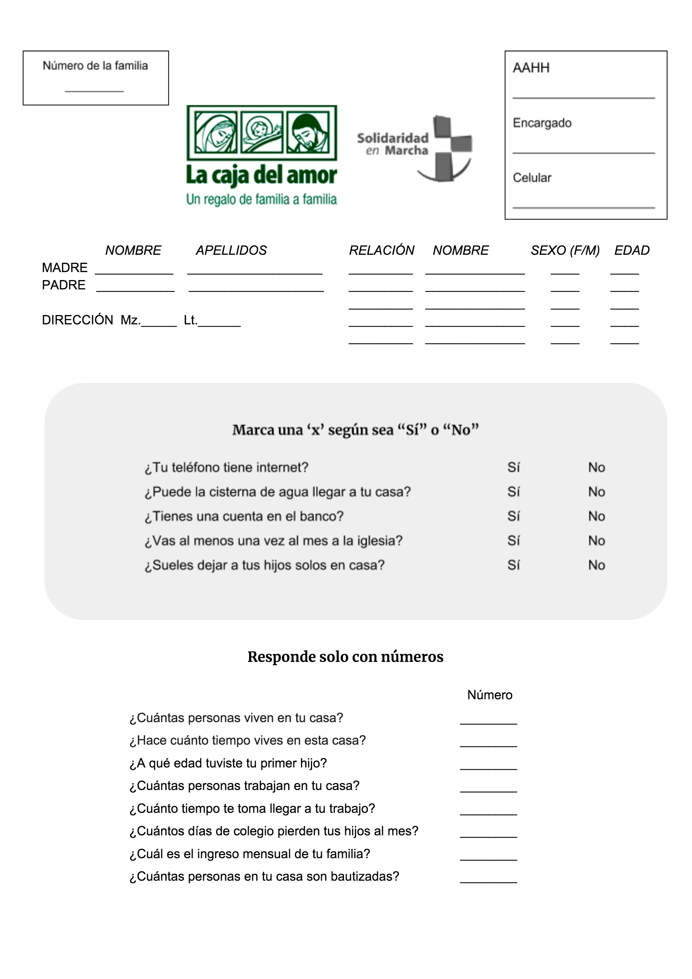

The completed dataset built from the original survey contains 21 variables and 507 observations of which to explore, visualize and perform analysis on. The complete dataset can be found on my GitHub account, [here](https://github.com/showmalley/SeanOMalleyCodePortfolio/blob/master/Development%20Economics/PovertySurveys/CDA_FULL_2018.csv). Also note, for binary variables, 1 is yes and 0 is no.

1. **fam_n** – *numeric* *factor* – Unique identifier for each family.
2. **internet** – *binary* – Does your phone have internet?
3. **agua** – *binary* – Can the water truck get to your house?
4. **banco** – *binary* – Do you have a bank account?
5. **iglesia** – *binary* – Do you go to church at least once a month?
6. **dejar_hijos** – *binary* – Do you leave your children home alone (when you go to work)?
7. **cuantas_personas** – *numeric* – How many people live in your house?
8. **tiempo_casa** – *numeric* – How long have you lived in your house?
9. **primer_hijo** – *numeric* – At what age did you have your first child?
10. **cuantas_trabajan** – *numeric* – How many people in your house work?
11. **tiempo_trabajan** – *numeric* – How long does it take to get to your job?
12. **pierden_colegio** – *numeric* – How many days a month do your children miss school?
13. **ingreso** – *numeric* – What is your monthly household income?
14. **bautizadas** – *numeric* – How many people in your family are baptized?
15. **direccion** – *character* *factor* – Name of neighborhood.
16. **padre** – *binary* – Does the father of the children live in the home?
17. **madre** – *binary* – Does the mother of the children live in the home?
18. **F** – *numeric* – Count of females in the home.
19. **M** – *numeric* – Count of males in the home.
20. **niños** – *numeric* – Count of children 18 and younger in the home.
21. **mayores** – *numeric* – Count of adults 65 and older in the home.

Months of conversations, meetings, reading and collaboration with community members came into building this survey. Qualitative analysis helped us produce a dataset that has the potential to perform multiple quantitative analyses that are relevant and informed; and it is from this point that we will now follow the flow of a data science analysis.

**Reminder:** I will at times use technical language, but I encourage you to keep reading through, because I will also accompany every scientific insight with an explanation in simple language, relevant to the question at hand.

We will begin by exploring the variables, the average values and basic correlations, visualizing how characteristics behave with one another. Following our exploratory phase, we will inspect cause and effect relationships between pairs of variables, as well as predict specific variables using all available data. I will use multiple techniques to perform this analysis of causality in hopes of providing variable importance in the prediction of key factors of the poor. The result will be a set of priorities for aid workers to pursue in the betterment of certain economic or societal indicators.

The succeeding analysis will be that of understanding natural segments that exist within the poorest of the poor. Again, using multiple techniques, I will attempt to determine the groups of people that exist within those surveyed. What commonalities do certain segments have? How can we target aid campaigns to help certain groups? These are a few of the many questions a segmentation analysis will help us answer.

Our quantitative and qualitative analyses will come to fruition in the final recommendation portion of this process. We will present questions and provide actionable insight into those questions, as determined by our analysis. We will build a road map for aid, a list of how we can help, who we can help and the logistical suggestions to do so. Our intent is to tie every insight to action and offer suggestions as to the best action available given what we have learned from the analysis. So, let’s get started!